Data Analysis Report for Apnaklub
Prepared By: Srinivasan Ramachandran
Date: 25/09/2024

1. Introduction
This report presents the key insights from an analysis of Apnaklub’s wholesale order dataset, aimed at providing valuable business intelligence. The data covers customer behavior, SKU performance, warehouse efficiency, and sales trends. The analysis focuses on identifying top-performing products, high-value customers, and warehouse performance, as well as opportunities for growth through targeted strategies.

2. Analysis Overview
Key Metrics Analyzed:
- Top 5 Best Selling SKUs
- Top 5 Best Selling SKUs in Each Warehouse
- Top 5 Highest GMV Customers
- Highest GMV Customers for Each Warehouse
- Top 5 Customers by Order Frequency
- Top Customers by Order Frequency for Each Warehouse
- Monthly Sales Trends
- Sales Trends by Warehouse
- Warehouse Performance
- Total Repeat Customers

3. Detailed Analysis & Business Insights
3.1. Top 5 Best Selling SKUs
Top SKUs:
aa61eaa (2187 units)
5c7951f (2108 units)
bd7c360 (1525 units)
5778589 (1504 units)
0934276 (1492 units)
Insights:
- These top 5 SKUs are the most popular products and drive significant revenue.
Recommendations:
- Inventory Prioritization: Keep these SKUs well-stocked to avoid any stockouts.
- Supplier Negotiations: Negotiate better terms with suppliers due to their consistent high performance.
- Promotion Strategy: Promote these SKUs more aggressively to drive sales further.

3.2. Top 5 Best Selling SKUs in Each Warehouse
Warehouse | Top SKU | Units Sold
India | 5c7951f | 757 units
USA | aa61eaa | 1051 units
United Kingdom | aa61eaa | 1062 units
Insights:
- The best-selling SKUs differ across regions, indicating that demand varies significantly by geography.
Recommendations:
- Tailored Inventory: Adjust inventory to match regional preferences. For example, ensure that SKU aa61eaa is fully stocked in the USA and UK warehouses.
- Regional Marketing: Implement region-specific marketing campaigns to promote the top SKUs in each location.

3.3. Top 5 Highest GMV Customers
User ID | Total GMV (₹)
864cd3a | 1,332,258.05
bdc234c | 1,184,905.64
3d890d3 | 1,088,147.31
d99ddb8 | 1,077,321.58
f3c7b62 | 1,063,854.26
Insights:
- A small group of customers contribute a large portion of the total GMV.
Recommendations:
- Customer Loyalty Program: Introduce a loyalty program for high-value customers, offering personalized discounts and promotions.
- Dedicated Support: Assign dedicated account managers to top customers to ensure continued satisfaction and encourage repeat business.

3.4. Highest GMV Customers for Each Warehouse
Top Customers:
- India: d99ddb8 (₹1,077,321.58)
- USA: 3d890d3 (₹1,088,147.31)
- United Kingdom: 864cd3a (₹1,332,258.05)
Insights:
- High-value customers are spread across all regions, with the UK leading in total GMV.
Recommendations:
- Region-Specific Retention: Focus on retaining top customers in each region by offering region-specific incentives and promotions.
- Customer Engagement: Regularly engage with these customers through personalized communications and promotions.

3.5. Top 5 Customers by Order Frequency
User ID | Total Orders
9e7da4c | 109 orders
295e624 | 93 orders
e3926ce | 78 orders
d99ddb8 | 75 orders
ca2a9e3 | 66 orders
Insights:
- Customers with high order frequency are not always the highest in GMV but show strong loyalty.
Recommendations:
- Cross-Selling: Offer these customers cross-sell opportunities to increase their order value.
- Loyalty Rewards: Implement rewards based on the frequency of orders to encourage even more repeat purchases.

3.6. Top Order Frequency Customers in Each Warehouse
Top Customers:
- India: d99ddb8 (75 orders)
- USA: 9e7da4c (109 orders)
- United Kingdom: e3926ce (78 orders)
Insights:
- High-frequency customers are concentrated in each warehouse.
Recommendations:
- Warehouse-Specific Promotions: Offer special promotions to frequent buyers in each warehouse to incentivize continued loyalty.
- Personalized Offers: Tailor product recommendations to frequent customers based on their purchasing history.

3.7. Monthly Sales Trends
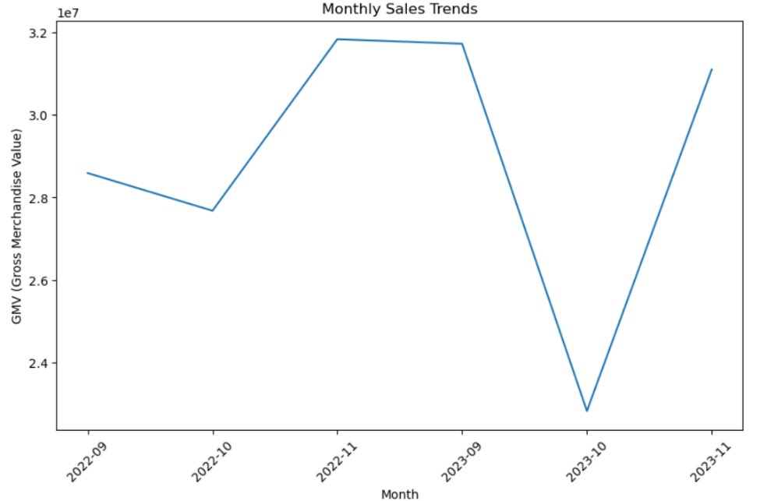
Graph Summary:
The line chart shows the Gross Merchandise Value (GMV) across months from September 2022 to November 2023.
- The GMV peaked in November 2022 and then significantly dropped in October 2023, before rebounding in November 2023.
Business Insight:
- There is a notable seasonal pattern with a spike in GMV during November 2022 and a drop around October 2023.
- Action: Focus on maintaining consistent stock levels during high GMV months like November, and investigate the cause of the sharp decline in October 2023 to prevent future occurrences.

3.8 Sales Trends by Warehouse
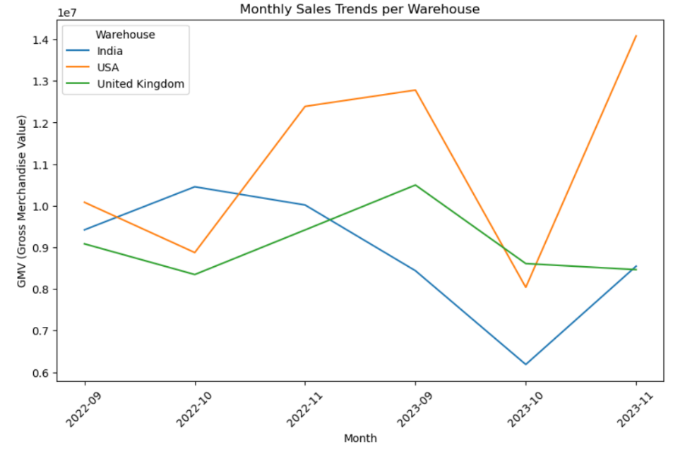
Graph Summary:
The second line chart visualizes the GMV for three different warehouses (India, USA, and UK) across the same time period.
- The USA warehouse consistently leads in GMV, with a peak in November 2022, followed by a significant dip in October 2023, before another increase in November 2023.
- India and the UK warehouses also show fluctuations, but with a more moderate GMV compared to the USA.
Business Insight:
- The USA warehouse performs the best overall but has experienced sharp fluctuations in GMV.
- Action: Improve inventory and sales strategies in the USA warehouse to stabilize performance. India and the UK warehouses have growth potential, so strategies could be developed to increase their contributions.

3.9. Warehouse Performance
Warehouse | Total GMV (₹) | Order Count
India | 53,066,153.46 | 6,080 orders
USA | 66,248,696.45 | 8,215 orders
United Kingdom | 54,423,087.40 | 6,844 orders
Insights:
- The USA warehouse leads in both GMV and order count, indicating higher demand.
Recommendations:
- Capacity Expansion: Consider expanding the USA warehouse’s capacity to handle more orders efficiently.
- Process Optimization: Evaluate the performance of the India and UK warehouses to identify bottlenecks or inefficiencies. Improvements in these areas could boost overall performance.

3.10. Total Repeat Customers
Total Repeat Customers: 2729
Insights:
- A significant portion of the customer base consists of repeat buyers, showing strong customer loyalty.
Recommendations:
- Retention Programs: Strengthen customer retention efforts through loyalty programs, exclusive offers, and excellent customer service.
- Customer Feedback: Engage repeat customers for feedback to further improve their experience and solidify their loyalty.

4. Conclusion
The data reveals valuable insights into product performance, customer behavior, and warehouse efficiency, providing several actionable strategies to improve Apnaklub’s operations. By focusing on inventory management, customer retention, and region-specific marketing, Apnaklub can enhance its overall performance and drive future growth.

